Assignment 1

1. What is machine learning? Where and why you will use machine learning?

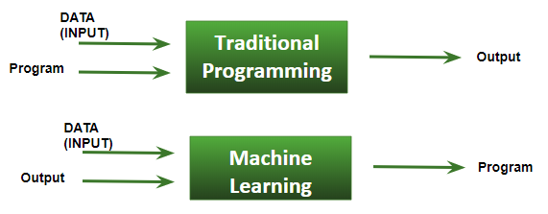
Machine Learning is the field of study that gives computers the capability to learn without being explicitly programmed. It gives the computer the ability to learn which makes it more similar to humans. Machine Learning(ML) can be explained as automating and improving the learning process of computers based on their experiences without being actually programmed that is without any human assistance. The process starts with feeding good quality data and then training our machines(computers) by building machine learning models using the data and different algorithms. The choice of algorithms depends on what type of data do we have and what kind of task we are trying to automate.

We feed in DATA(Input) + Output, run it on machine during training and the machine creates its own program(logic), which can be evaluated while testing.
Machine learning is needed for tasks that are too complex for humans to code directly. Some tasks are so complex that it is impractical, if not impossible, for humans to work out all of the nuances and code for them explicitly. So instead, we provide a large amount of data to a machine learning algorithm and let the algorithm work it out by exploring that data and searching for a model that will achieve what the programmers have set it out to achieve.
Applications of Machine Learning :
- Face Recognition
- Image Recognition
- Fraud detection
- Web search
- Recommendation system.
- Financial Market Analysis
- Internet Fraud detection
- Time Series Forecasting
- Agriculture
- DNA sequence
- And many more places

2. What is the difference between data mining and machine learning?

Both data mining and machine learning are rooted in data science and generally fall under one umbrella. Although there is a strong correlation and considerable overlap between the two, they are distinct and have different applications.
To implement data mining techniques,two-component used first one is the database and the second one is machine learning. The Database offers data management techniques while machine learning offers data analysis techniques. But to implement machine learning techniques algorithms has been used.
Data mining uses more data to extract useful information and that particular data will help to predict some future outcomes for example in a sales company it uses last year data to predict this sale but machine learning will not rely much on data it uses algorithms, for example, OLA, UBER machine learning techniques to calculate the ETA for rides.
Self-learning capacity is not present in data mining, it follows the rules and predefined. It will provide the solution for a particular problem but machine learning algorithms are self-defined and can change their rules as per the scenario, it will find out the solution for a particular problem and it resolves it by its own way.
Although Machine learning and data mining use the same key algorithms to discover patterns in the data. However their process, and consequently utility, differ. Unlike data mining, in machine learning, the machine must automatically learn the parameters of models from the data. Machine learning uses self-learning algorithms to improve its performance at a task with experience over time. It can be used to reveal insights and provide feedback in near real-time.
The result produces by machine learning will be more accurate as compared to data mining since machine learning is an automated process.
Machine learning, for example, can be used to continuously monitor the performance of equipment and events and automatically determine what the norm is and when failures are likely to occur. When new data sets are introduced or trends change, machine learning incorporates that information to determine the new norm without people needing to go back in and reprogram baselines or key performance indicators. This ability to learn and adapt makes it the optimal choice for improvements in ongoing processes, marketing campaigns and continuous customer service improvements.
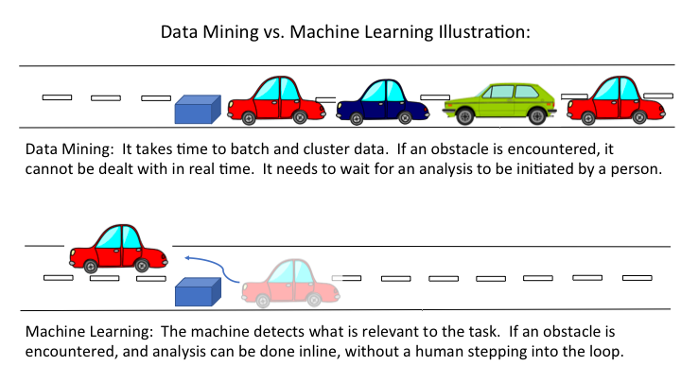

3. What is normalization and why do you perform? Explain with examples. How do you perform it?
Normalization is often applied as part of data preparation for machine learning. The goal of normalization is to change the values of numeric columns in the data set to a common scale, without distorting differences in the ranges of values. When you normalize a feature, all feature values will be in the range of 0 to 1.This improves the performance and training stability of the model. For machine learning, every data set does not require normalization. It is required only when features have different ranges.
So normalization in statistics basically means:
I have data set 1 with possible values from 0-1000 randomly distributed.
I have data set 2 with possible values from 0-1 randomly distributed.
If I want to compare the distributions between data set 1 and data set 2 I would normalize the data by either dividing every value in data set 1 by 1000 or multiplying every value in data set 2 by 1000. Then the 2 data sets are comparable and can be merged.
Example:
Some machine learning algorithms require the input data to be normalized in order to converge to a good result.
Let's take for example a data set where samples represent apartments and the features are the number of rooms and the surface area. The number of rooms would be in the range 1-10, and the surface area 200 - 2000 square feet. Both features are uniformly distributed and independent.
Before scaling, the data could look like this (note that the axes are proportional)
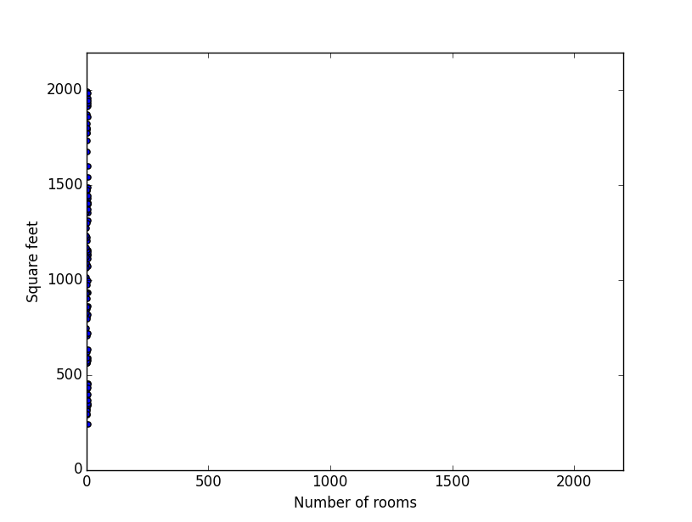
You can see that there is basically just one dimension to the data, because of the two orders of magnitude difference between the features.

After standard scaling, the data would look like this (note that the axes are proportional):
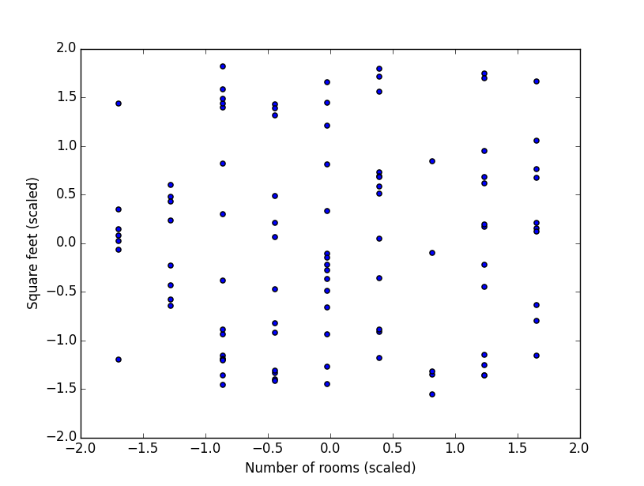

Now the data is nicely distributed and a logistic regression or SVM could do a much better job classifying the sample.

Advantages of Normalization:
- The main advantage of normalization is to avoid attributes in greater numeric ranges dominating those in smaller numeric ranges.
- Normalization increases the speed and accuracy benefits.
- When using the Logistic Regression and Averaged Perceptron algorithms, by default, features are normalized before training.
- The point of normalization is to change your observations so that they can be described as a normal distribution.
Normal distribution (Gaussian distribution), also known as the bell curve, is a specific statistical distribution where a roughly equal observations fall above and below the mean, the mean and the median are the same, and there are more observations closer to the mean
x′=x−xmean / xmax−xmin
For normalization, the maximum value You can get after applying the formula is 1, and the minimum value is 0. So all the values will be between 0 and 1.

4. What is standardization and why do you perform? Explain with examples.
Standardization (or Z-score normalization) is the process of re-scaling the features so that they’ll have the properties of a Gaussian distribution with a mean value of 0 and a standard deviation of 1. Standardization assumes that your data has a Gaussian (bell curve) distribution. This does not strictly have to be true, but the technique is more effective if your attribute distribution is Gaussian. This works better with linear regression, logistic regression and linear discriminate analysis.
Standardizing tends to make the training process well behaved because the numerical condition of the optimization problems is improved. The main goal of standardizing features is to help convergence of the technique used for optimization.
Standardization can drastically improve the performance of models. For instance, many elements used in the objective function of a learning algorithm (such as the RBF kernel of Support Vector Machines or the l1 and l2 regularizes of linear models) assume that all features are centered around zero and have variance in the same order. If a feature has a variance that is orders of magnitude larger than others, it might dominate the objective function and make the estimator unable to learn from other features correctly as expected.
Standardization helps to make all variables fit into the same scale, while also maintaining their internal variance and not affecting their relative importance.
If we used variance to normalize X axis, and standard deviation for y axis, it'll in effect change the variable scales and as such would inadvertently tell the algorithm that X is the more important variable than y, something we don't want. So we use the standard scaler so as to maintain the variance both within a variable, and between variables.
Standardization rescales data to have a mean (μ) of 0 and standard deviation (σ) of 1 (unit variance).

X Changed=X−μ /σ
For most applications standardization is recommended

5. What is supervised and unsupervised learning? Give some examples.
Supervised Learning
Supervised Learning deals with those class of problems where we know what are the outputs. For example, in Loan Application System, output is already known as
1. Loan Approved 2. Loan Rejected.
Similarly in House Price Prediction System we already know the output price of house for past data.
So the idea is if a machine can go through the past data and its output it can probably understand the hidden correlation and pattern between data and its effect on output. This is known as training or supervising phase.
Supervised Learning is the most widely used machine learning technique now a days because companies are making used of past data within the organization to make predictions about their business, customers, risks etc. Below are some popular use cases of supervise learning –
- Spam Detection
- Loan Approval System
- Image classification
- Recommended System
- Medical Diagnostic System
- Stock Price Prediction
- Handwriting or Speech recognition
8. Weather Forecast System
Supervised learning problems can be further divided into two parts, namely classification, and regression.
Classification: A classification problem is when the output variable is a category or a group, such as “black” or “white” or “spam” and “no spam”.
Regression: A regression problem is when the output variable is a real value, such as “Rupees” or “height.”

Unsupervised Learning
Unsupervised learning deals with those class of problems where output is not known beforehand. We are looking for some answers from the data but do not know the precise answers before hand. Since we don’t have the output answer with us there is no training phase either.
For example let us assume a popular retail company wants to understand its customer groups so that it can do some targeted ad campaign to those groups. It does not have answer to it upfront. We feed customer’s data and its purchase history into unsupervised learning system and asks it to divide the customers into say 10 groups. The machine will do some crunching and produce 10 groups of customers.
Customer in each group will have something in common. In one group customer might be of similar income class. Customers in other groups might be showing similar purchase pattern. In some other group customers might be showing similar expenditures. And so on. With this segmentation in hand, company can now start targeting customers of each group separately with promotions and offers.
It is worth noting that we did not know before hand what characteristics each group will have, that is we had no answer before we actually did unsupervised learning. This technique of unsupervised learning is known as Clustering.
Some of the popular use case of unsupervised learning are –
- Customer Segmentation
- Image Segmentation
- Market Basket Analysis
- Fraud Detection
- Anomaly Detection
Unsupervised learning problems can be further divided into association and clustering problems.
Association: An association rule learning problem is where you want to discover rules that describe large portions of your data, such as “people that buy X also tend to buy Y”.
Clustering: A clustering problem is where you want to discover the inherent groupings in the data, such as grouping customers by purchasing behavior.

